[2026-03-12]AIX+系统邮件

目录
[同步块-无权限下载此内容]

1. 需求背景
支持aix项目的多语言能力

2. 需求概况
类型 | 明细
PM | @Bing Han 韩冰
需求方
UI/UX
前端
服务端
测试
Figma
BRD
期望上线时间
Meggle
关联域PRD
历史需求PRD
技术方案
支持语言
设备适配
链接
文案review
Others

3. demo
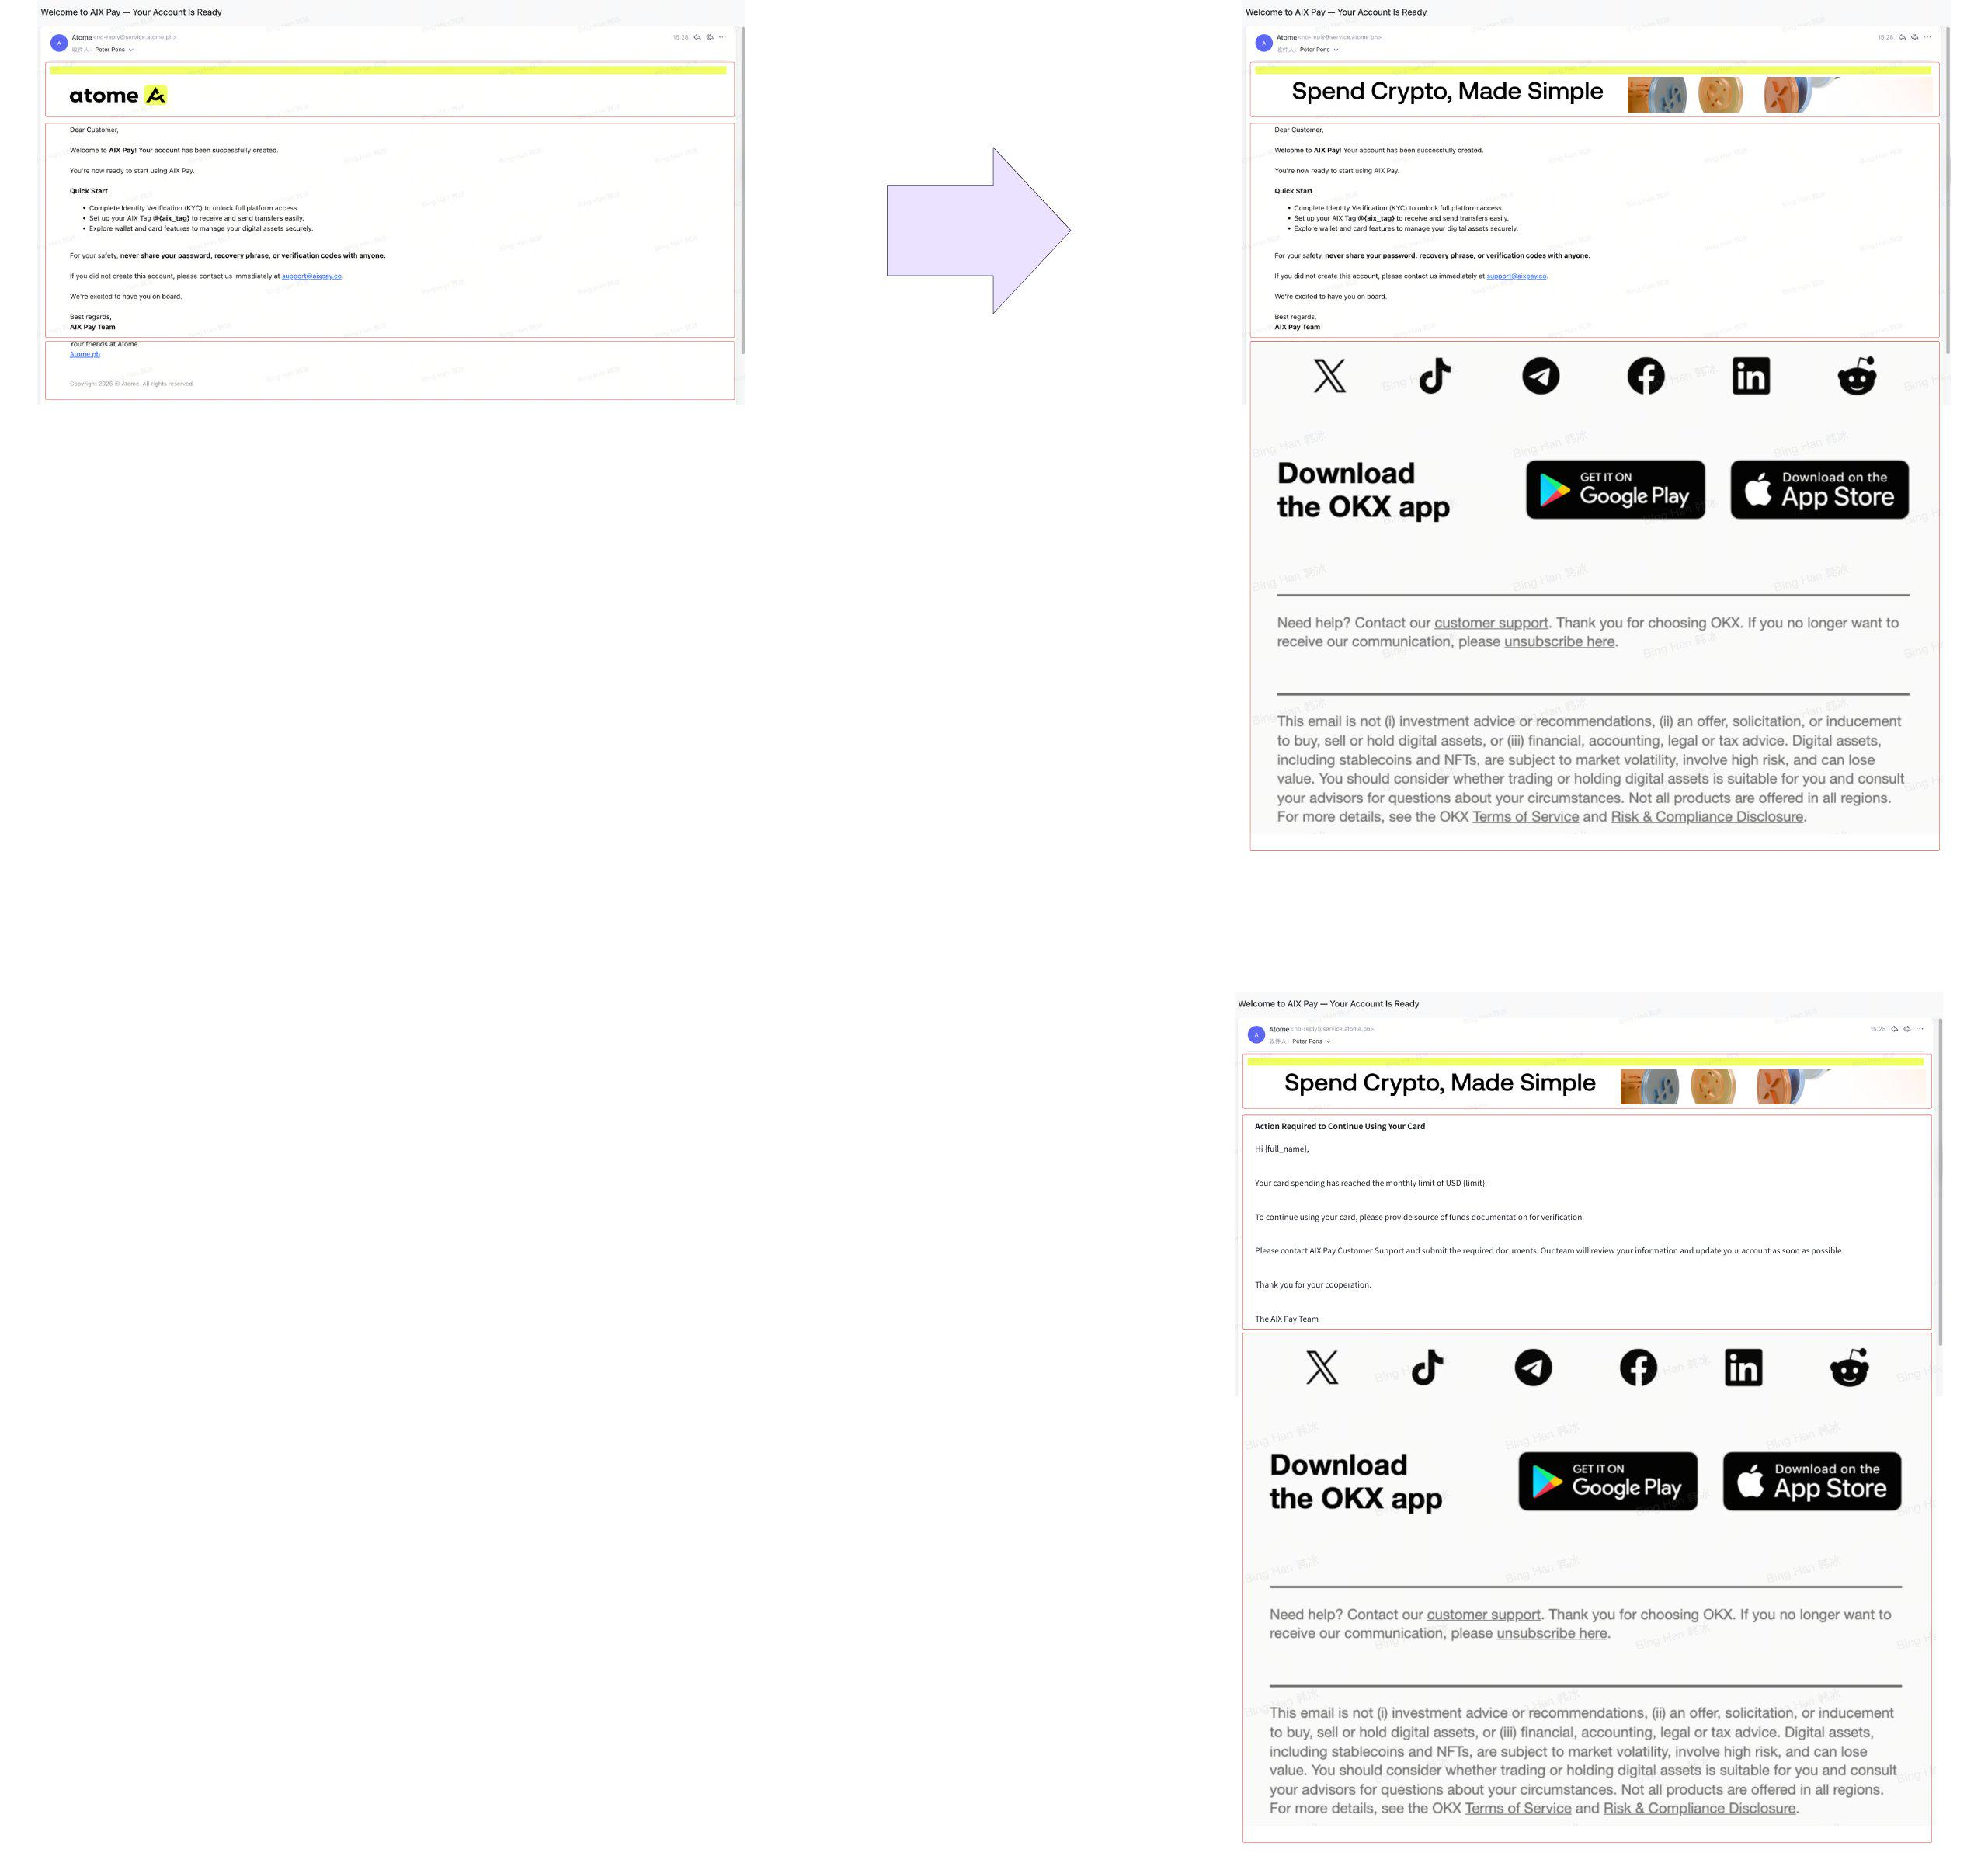

Basic information：
- This project just includes the AIX, not atome.
- The template needed to be designed, including : logo banner+body+footer; the design team is working on the ui designed.
- Currently, we have already implemented the Moenage standard protocol and at the technical level we can send emails.
- System email content：AIX【System Notification+content】

Questions:
- Regarding the system email, will the template, which includes logo banner+body+footer be configured in MoEngage, or not?
- Regarding the system email, will the email body be configured in MoEngage, or not?
- Regarding the promotion email, will the template, which includes logo banner+body+footer be configured in MoEngage, or not?
- Regarding the promotion email, will the email body be configured in MoEngage, or not?

- Create the template. Do we need to call this interface:https://developers.moengage.com/hc/en-us/articles/18187641060244-Create-Email-Template-API#01GQRA6BGSEZA2F6DR6NA2BBDA

4. Interface interaction

4.1 System email
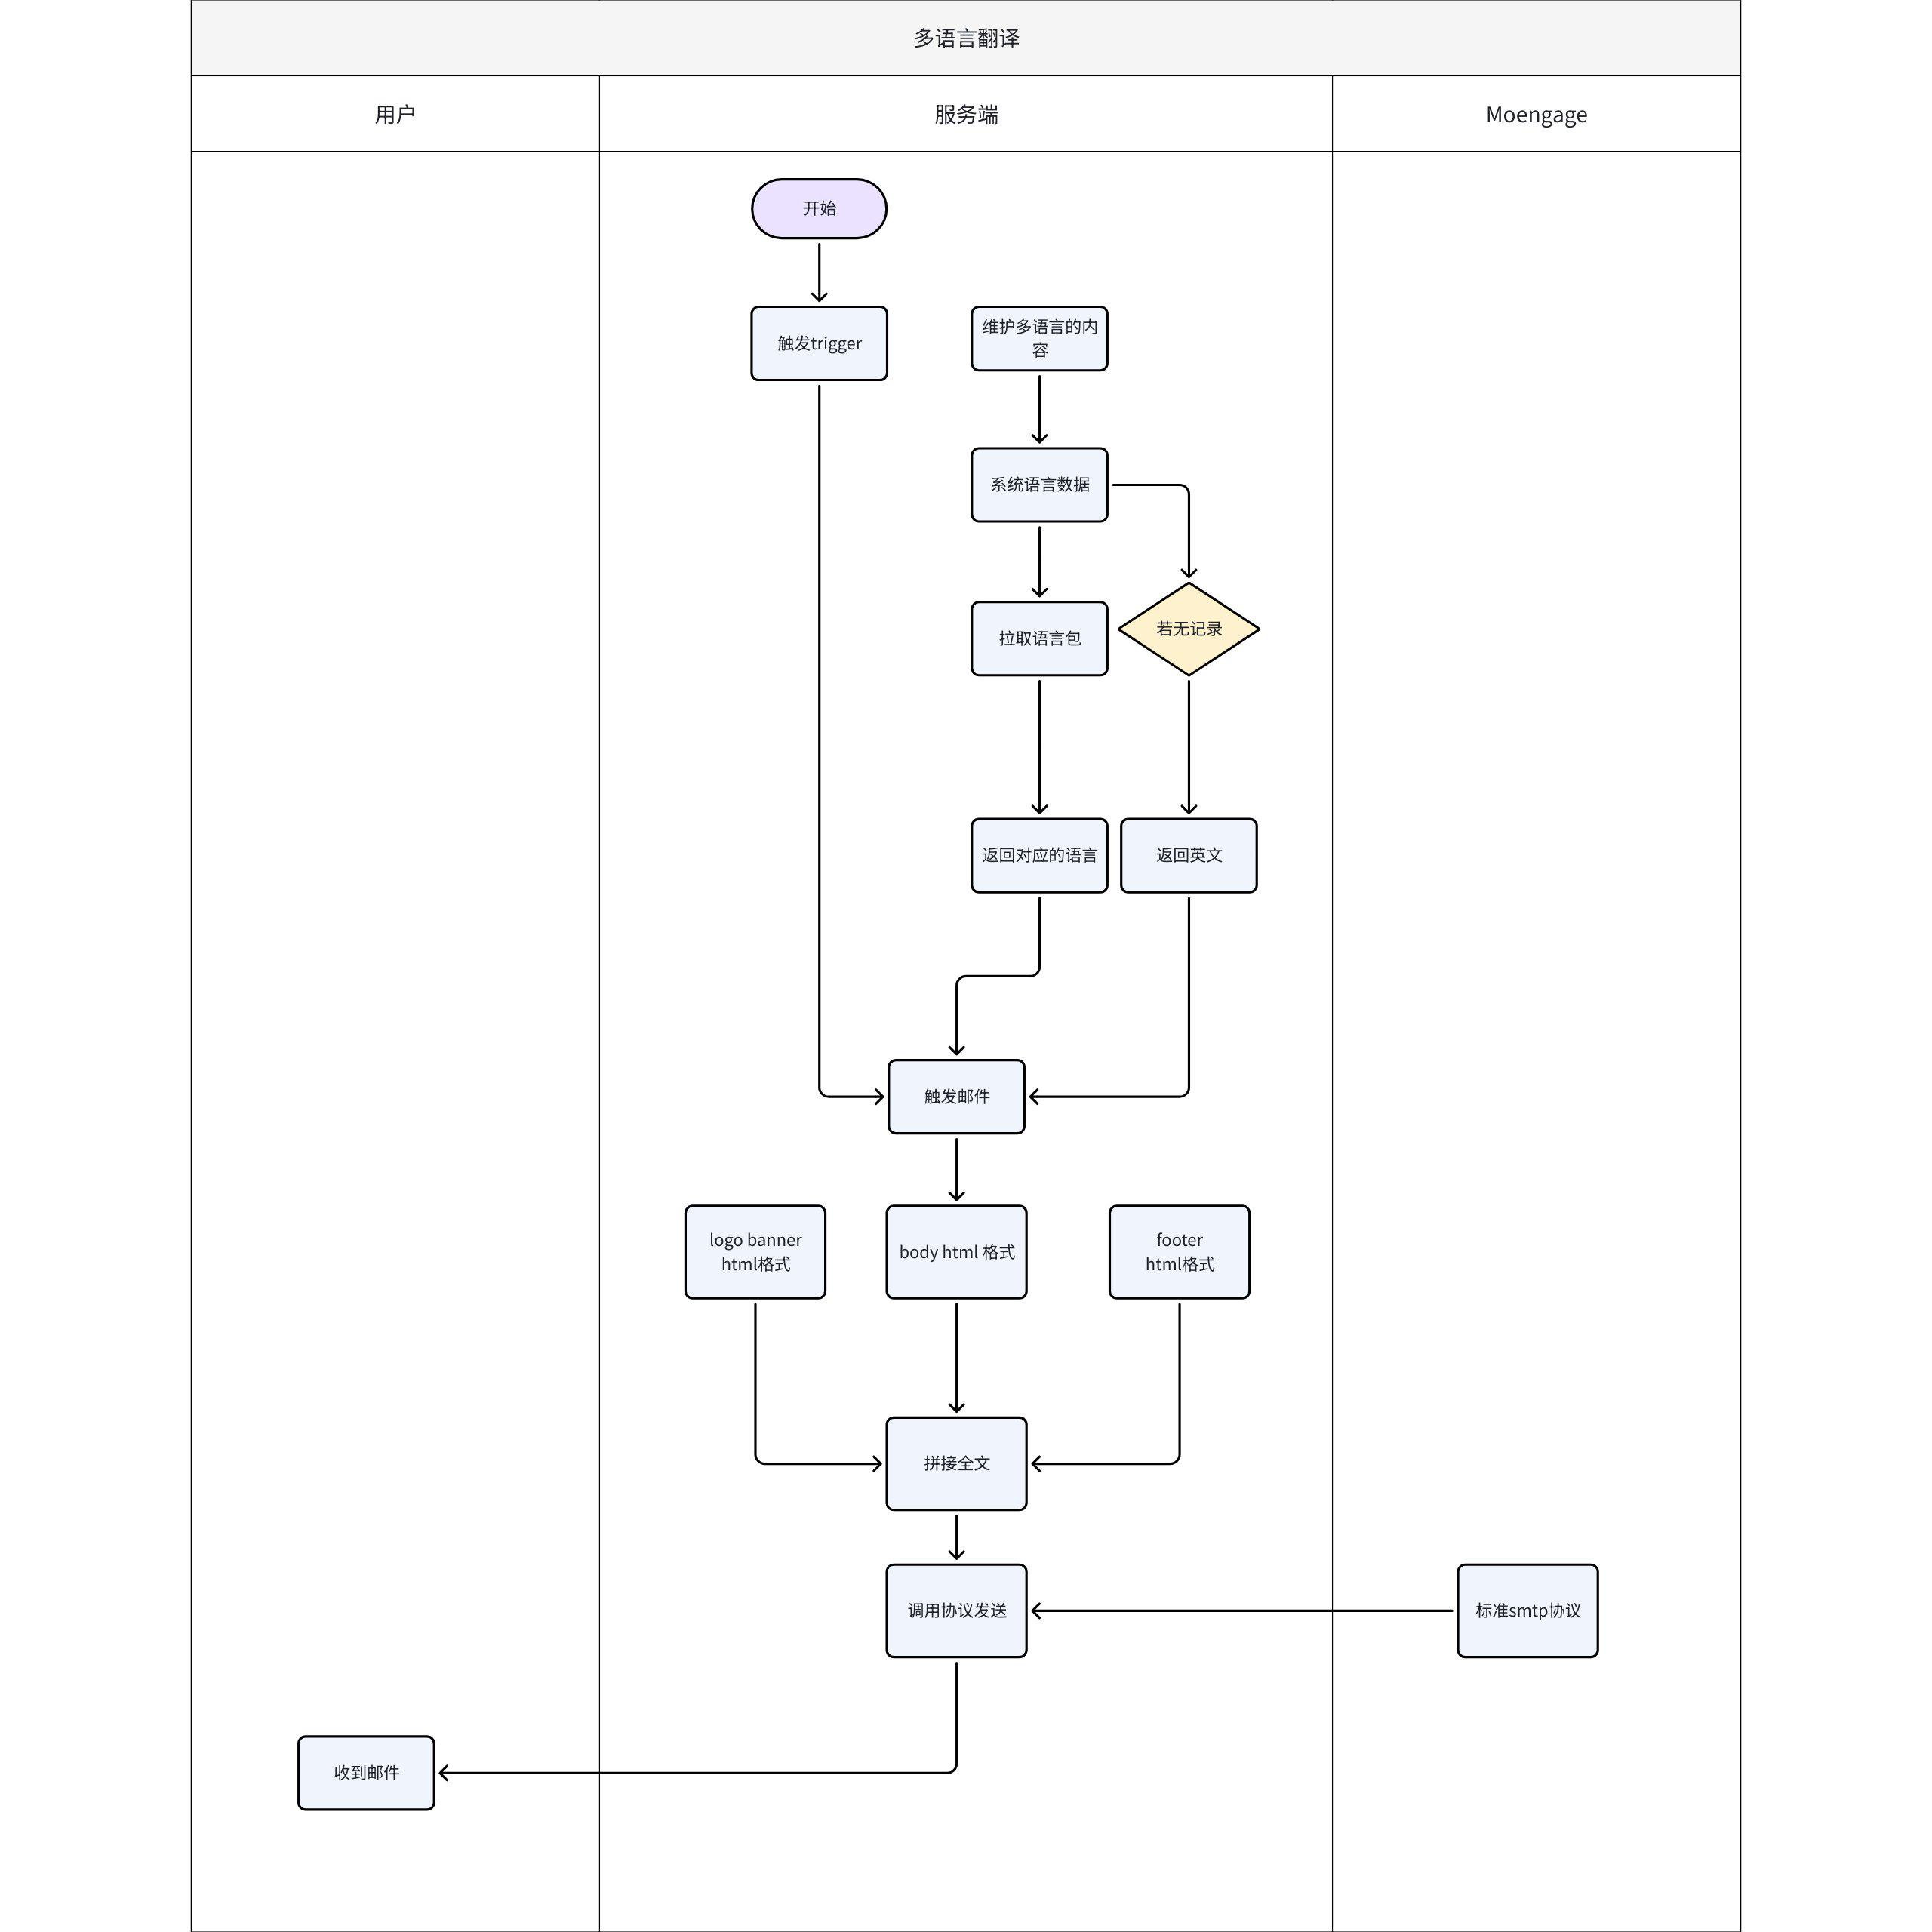

5. 数据埋点
待定

6. 数据分析需求（待定）

7. 参考资料
[AIX]Email Design & Template Requirement

